Pong User Guide:

Pong is a simple game in which the aim is to hit the ball. You move your paddle yourself. If you don’t hit the ball you will lose a point. In this version of Pong the game the player who wins is the first player to score 5 points.

Controls:
Player 1 – Left Player | Player 2 – Right Player
W – Left Paddle Up | U – Right Paddle Up
S – Left Paddle Down | J – Right Paddle Down

Other Controls:
Esc – Escape/Quit the game
Enter - To restart the program when a player has won
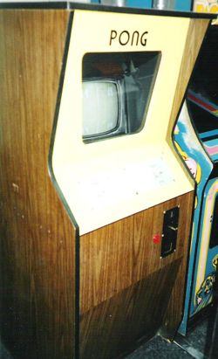
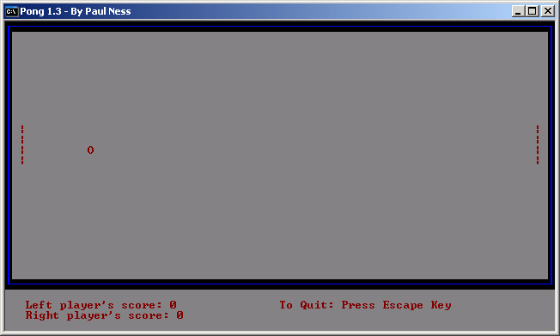

System Requirements:

Keyboard
Computer that can run .exe console files (i.e. Windows)
Monitor

